Jefferson County Fire Protection District No. 2

Commissioner Art Frank Commissioner Herbert Beck
Chairman of the Board Commissioner Melody Bacchus

P.O. Box 433, Quilcene, WA 98376 360-765-3333 fax: 360-765-0133

BOARD FOR VOLUNTEER FIREFIGHTERS PENSION & RELIEF BUSINESS: MOTION: Commissioner Art Frank moved to accept and add Sophia Knutzen and Kim Kittelson to the rolls. Commissioner Melody Bacchus seconded the motion. The motion carried with 3 yes votes.

CALL TO ORDER: Chair Commissioner Art Frank called the Regular meeting of the Board of Commissioner of February 10, 2020 to order at 7:00 pm. Commissioner Art Frank, Commissioner Melody Bacchus, Commissioner Herbert Beck, Chief Tim McKern, Deputy Chief Don Svetich, Secretary Jean Morris, Lieutenant Mark McCrehin, FF Thane Grooms, FF Roland Faragher-Horwell, Bob Rewitzer, David Neuenschwander, Tom Brotherton, Cass Brotherton and Linda Herzog were in attendance.

THE PLEDGE OF ALLEGIENCE WAS SAID.

APPROVAL OF AGENDA: MOTION: Commissioner Art Frank moved to accept the agenda with the addition of Budget and accounting under New Business #3. Commissioner Melody Bacchus seconded the motion. The motion carried with 3 yes votes.

APPROVAL OF MINUTES: MOTION: Commissioner Art Frank moved to accept the minutes of the January 13, 2020 Regular meeting a presented. Commissioner Melody Bacchus seconded the motion. The motion carried with 3 yes votes.
MOTION: Commissioner Art Frank moved to accept the minutes of the January 30, 2020 Special meeting as presented. Commissioner Melody Bacchus seconded the motion. The motion carried with 3 yes votes.

APPROVAL OF VOUCHERS: Upon review of the voucher prior to the meeting by Commissioner Art Frank MOTION: Commissioner Art Frank moved to accept and sign the General Fire Vouchers in the amount of $90,978.67 and the EMS vouchers in the amount of $23,317.42 as presented. Commissioner Melody Bacchus seconded the motion. The motion carried with 3 yes votes.

MONTHLY FINANCIAL REPORTS: The Monthly Financial Reports were reviewed.

CORRESPONDENCE.: The list of Monthly Correspondence was read.

CHIEF’S AND OFFICIERS REPORTS:

FIRE CHIEF Tim McKern

Governance and Administration:
    - EMS Training – Pediatric Conference June 4 Port Ludlow Beach Club ALNW/ Jefferson Co. EMS
    - EJFR will be hosting a Child Passenger Safety Technician Class 2/24 – 27/2020 at station 11.
    - Station 21 Construction Project update
    - New EMS Protocols complete out for final review and approval.
    - Knox Box location and potential key secure for apparatus

Goals and Objectives:
    - Station 22 Station and Equipment Repairs
    - PPE inventory ongoing / AFG Grant
    - AFG Safer and Tender Closeout
    - Radio and Pager inventory and needs assessment

Financial Resources:
    - NSTR
    - GEMT review and update with System Design. Concern that Nov/Dec 2019 had no GEMT revenue. SD to review. SD to send out a Report writing trainer to give us updated medical billing terms.
    - Reviewing the PILT and School per student revenue that County receives

Physical Resources and Quality of Life (QOL):
    - Microsoft Office- LT Winn-Ongoing
    - Residence home and ADA- pending permits and progress review with AA Construction

Health and Safety
    - Industrial Hygienist-Department of Labor & Industries (10/2): Initial visit completed. Diesel particulate testing (12/4) No information yet – Will follow up with LNI
    - Volunteer physicals -Looking into another clinic and review of annual Respiratory Questionnaire

Essential Resources
    - Policy & Procedure- Lexipol- QFR Policy consolidation. 16 for review (emailed and printed)

External Relationships
    - Company Officer Blue Card ICS Training-Ongoing

Fire Prevention

Community Risk Reduction programs to start with IFSTA Essentials of CRR programs for staff
Discussed the Bias System.
Working on the Knox Box System.
Working with Target Solutions.
Lieutenant McCrehin and Chief meeting with AA Solutions.

Deputy Chiefs Report Don Svetich

- Significant Events and Service Delivery:
  - Slow month. Most BLS aid calls, variety of sick people, vehicle accidents, Two Structure fire in one in Brinnon and one in Chimacum both where tender responses.

- Apparatus Readiness: All apparatus in services and available.
Vehicle Replacement Plan (2018-2045), Due for yearly review and updating.
New Command Rig is on District, final outfitting.
Lt. McCrehin’ s report will cover any additional Apparatus status.

Training and Competency
- Basic Firefighter Academy: New Academy scheduled in North Kitsap.
- EMT Training: The EMT class is under way, we have Four individuals I the class. Shelby Coryell, Zach Torres, Damon Edwards and a new recruit, Sophie Knutzen
- EMS Connect is live, some minor problems with connecting and finding current month training subject but is generally improving with use and time. Currently have 13 EMTs on EMS Connect.
  - JEFFCO Training Consortium status: No Updates, Will be discussing Target Solutions with Chief McKern.

- Emergency Medical Services:
  - GEMT: Ground Emergency Medical Transportation:
- No Updates.

- Human Resources and Staffing (next 60 days)
- Anticipated time out of the office {AL}No time scheduled until April.

5. Historical Call numbers for each year:
  - Finished 2019 with 530 total calls for Service.
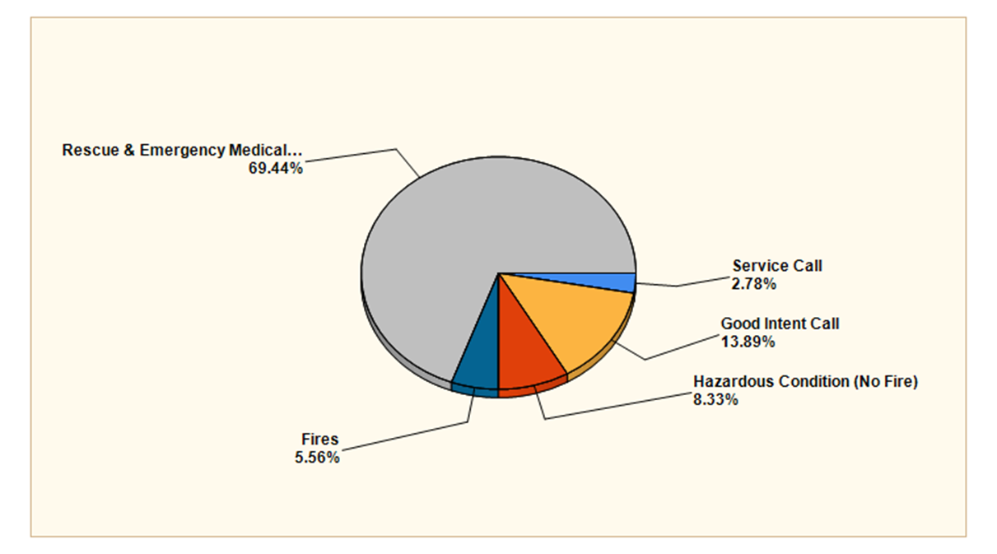

MAJOR INCIDENT TYPE | # INCIDENTS | % of TOTAL
Fires | 2 | 5.56%
Rescue & Emergency Medical Service | 25 | 69.44%
Hazardous Condition (No Fire) | 3 | 8.33%
Service Call | 1 | 2.78%
Good Intent Call | 5 | 13.89%
TOTAL | 36 | 100.00%

7. Other: On Boarding Chief McKern.

- End of Report

A-Shift Officers Report Lt. Mark McCrehin

- Apparatus Readiness:
- B22 was OOS for inspection and repairs. It was taken to Mountain Mechanic. With inspections completed, B22 is currently at Station 22 and back in service.
- T21 is currently at NKFR for an Annual Inspection. Once it is returned E21 and then E22 will receive annual inspections.
- The current C201 was delivered to Flying Wrench for transmission inspection and repair. It is to be returned to Station 21 to be refitted to a QRV (Quick Response Vehicle) and sent to Coyle.
- The New Command Rig has arrived. I have been in contact with vendors to have the outfitting completed. Currently I am researching different styles of shelves/boxes that can be outfitted into the rear cargo space of the vehicle. Lt Winn is in communication with Action Communication regarding radios.

- Training and Competency:

- Lexipol Tier 1 review should be completed and submitted for Commissioner review by Feb 4.
- Currently QFR has 3 members in the current EMT class. Damon Edwards, Shelby Coryell, and Zak Torres. They are currently 1 month into class. All 3 members say that class is difficult, but they are making their way through. All 3 members are consistently seen at Station 21 to study.

- Physical Resources and Quality of Life:
- The gym located in the garage at the Resident house has been repainted and foam flooring ordered. This work has been completed by Lynne Cassella-Blackburn.
- I am currently awaiting quotes back concerning new Station T shirts.
- New windows for Station 21 are scheduled to be delivered on Monday Feb. 3
- Permit for the ADA ramp at the Admin office has been approved. I am currently awaiting a projected start/finish date
- I have attached a proposal that was originally given to Chief Montone before his resignation. This proposal is for the kitchen area in Station 21. It is a proposal to update the current accommodations.

- Staffing (next 60 days):

- For the month of February, QFR has a full roster supporting a minimum staffing of 2.
- We will once again have members riding along as a third for the month of February to further their training and skills.

B-Shift Officers Report Lt. Kevin Winn

- Significant Events and Service Delivery:
- Responded mutual aid to Brinnon for CPR in progress on 01/14.

- Responded to a Water Rescue/SAR call on 01/31.

- Training and Competency:
- Lynne and I will be attending the IV Tech class in Mason County during the month of March.

- Physical Resources and Quality of Life:
- The G1 pager I sent in for repair has returned and has been issued to Art Frank.

- I will be working with Bob to get the information needed to apply for an AFG Communications Grant to upgrade our aging pager and radio equipment.

- I have been working with POE on department IT issues and getting the office 365 email setup.

- I am working with Lynne to come up with a volunteer onboarding timeline and training agreement.

- We have updated our HIPAA and AMA forms.

- Staffing (next 60 days):
I have no vacation or PTO planned for the month of Februa

C- Shift Officers Report LT Nick Singleton

- Significant Events and Service Delivery:
- C-Shift responded to a total of 13 calls for the month of January, the majority being aid calls with a couple of service calls.
- We responded to a residence on E Quilcene Road for a carbon monoxide alarm and found the 3 story house was filled with carbon monoxide due to a propane powered back up generator. FF Torres and I ventilated the home and took the opportunity to educate the homeowner about carbon monoxide gas and the importance of carbon monoxide detectors. We recommended the homeowner purchase additional battery powered CO detectors for each floor of the house.
- We received a phone call from property owners having a house built down at the end of Lindsay Hill Road. The property owner asked about ideal locations to mount fire extinguishers in their home. FF Torres and I offered to come out to the home and do a walk through. We used this as an opportunity not only to educate the homeowners on fire extinguishers, but to do a pre-plan/familiarization of the house and discuss building construction. The homeowners were very proactive and grateful to have their questions and concerns answered. They advised they would be willing to provide QFR with the blueprints of the home but I have not heard anything further.

- Apparatus Readiness:
- The 600ft of 1 ¾” hose has been received, inventoried, and placed in service.
- I have started the annual maintenance of the small powered tools. The Stihl chainsaw on E21 was taken to Olympic equipment rentals in Port Hadlock. I will be taking the majority of these tools to be inspected and maintained and expect this project to be complete within the next two months.
- I have ordered two, 2 ½” gate valves. One will replace the leaking gate valve on E22 and the other will be stored and ready in the event one fails.

- Training and Competency:
- I have been through a couple of the training modules on EMS connect and will be spending extra time going back and watching more videos. The detail and the way the information in delivered in the videos is excellent.
- FF Torres has been regularly studying for his EMT hours a day on shift, he is motivated and excited to start practicing his patient assessments. I have been taking time to review his quizzes and tests with him as often as possible. Volunteer Shelby Coryell has also been coming into the station to spend a lot of time studying, she is retaining the information well and has had a few opportunities to receive in service training during patient transports.
- Blue Card training is progressing well. I am approximately 2/3rd of the way though the modules and will continue to chip away at them. My goal is to have all modules complete within a couple weeks.
- I am looking into the regional small engines/chainsaw maintenance class. I would like to get certified to work on small engines like chainsaws and generators. As the officer in charge of small tools and rescue equipment I would like to know all I can about these tools. Having certified maintenance personnel on site can save money long term as well.

- Physical Resources and Quality of Life:

- I met with Mark LeMay from MES and received quotes on many different types of equipment to compare with what we have purchased in the past. He also sized Chief McKern for bunker pants as we did not have any bunker pants that fit upstairs in storage. I will be ordering Chief McKern bunker pants, as well as passport tags later this week.
- FF/EMT Josh Washburn is in need of bunker gear that fits appropriately. He will be meeting with Jana From SeaWestern to be sized for bunker gear on 2/7. I will be ordering FF/EMT Washburn new bunker gear shortly after that as well.
- I received passport tags for our new personnel and they are being issued.
- Fire Fighters without borders in currently not accepting donations for bunker gear and communication with them is slow. I will be meeting with Chief McKern to explore other avenues for donation.

- Staffing (next 60 days):
- NTR.

- Other:
- I will be meeting with Chief McKern to discuss my responsibilities and current projects. Having a new Chief’s feedback on all that I have taken on in the last few months should allow be to take a step back and prioritize. I will have a much more detailed report on projects in my next officers report and I thank you for your patience.

UNFINISHED BUSINESS:
1. Staffing: MOTION: Commissioner Art Frank moved to accept and sign the Interim Chief’s contract. Commissioner Herbert Beck seconded the motion. The motion carried with 3 yes votes.
Commissioner Herbert Beck spoke on the staffing issues. Investigated sharing a Chief and feels it just does not work. Has been working on figures to pay volunteers more.
2. Surplus Expired turnout gear (Resolution #2020-01): Tabled until next month.

NEW BUSINESS:
1. Chief Frank Montone (compensation and closeout of employment): Tabled until next month.
2. Policies:205,205,328.703,911,1017,1025,1027,1031,1032,1034, 1038,1029,1041,1044. MOTION: Commissioner Art Frank moved to accept the policies as presented. Commissioner Melody Bacchus seconded the motion. The motion carried with 3 yes votes.
3. Budget and Accounting: Discussed the Bias accounting System. Chief Tim McKern in checking into this.

SECRETARY REPORT: None.

SEMINARS/CONFERENCES/SPECIAL EVENTS: Commissioners Secretaries meeting Thursday, February 20, 2020, Brinnon.

PUBLIC INPUT-GOOD OF THE ORDER: Tom Brotherton ask about the Capital project fund.
Roland Faragher-Horwell asked what happens 4/15 when the Chief’s contract expires. Will be address in future meetings Discussed being a volunteer and in what rolls a person can volunteer. It was suggested that the District advertise what volunteer jobs are available and what training a person needs to do certain jobs within the department.

EXECUTIVE SESSION: None.

ADJOURNMENT: Chair Commissioner Art Frank called for adjournment at 8:15 pm.

SIGNED for Jefferson County Fire Protection District No. 2

BY:______________________________________________
ART FRANK, Commissioner, Chair of the Board

BY:______________________________________________
HERBERT BECK, Commissioner

BY:______________________________________________
MELODY BACCHUS, Commissioner

ATTEST
BY:____________________________________________________
Helen Jean Morris, District Secretary

